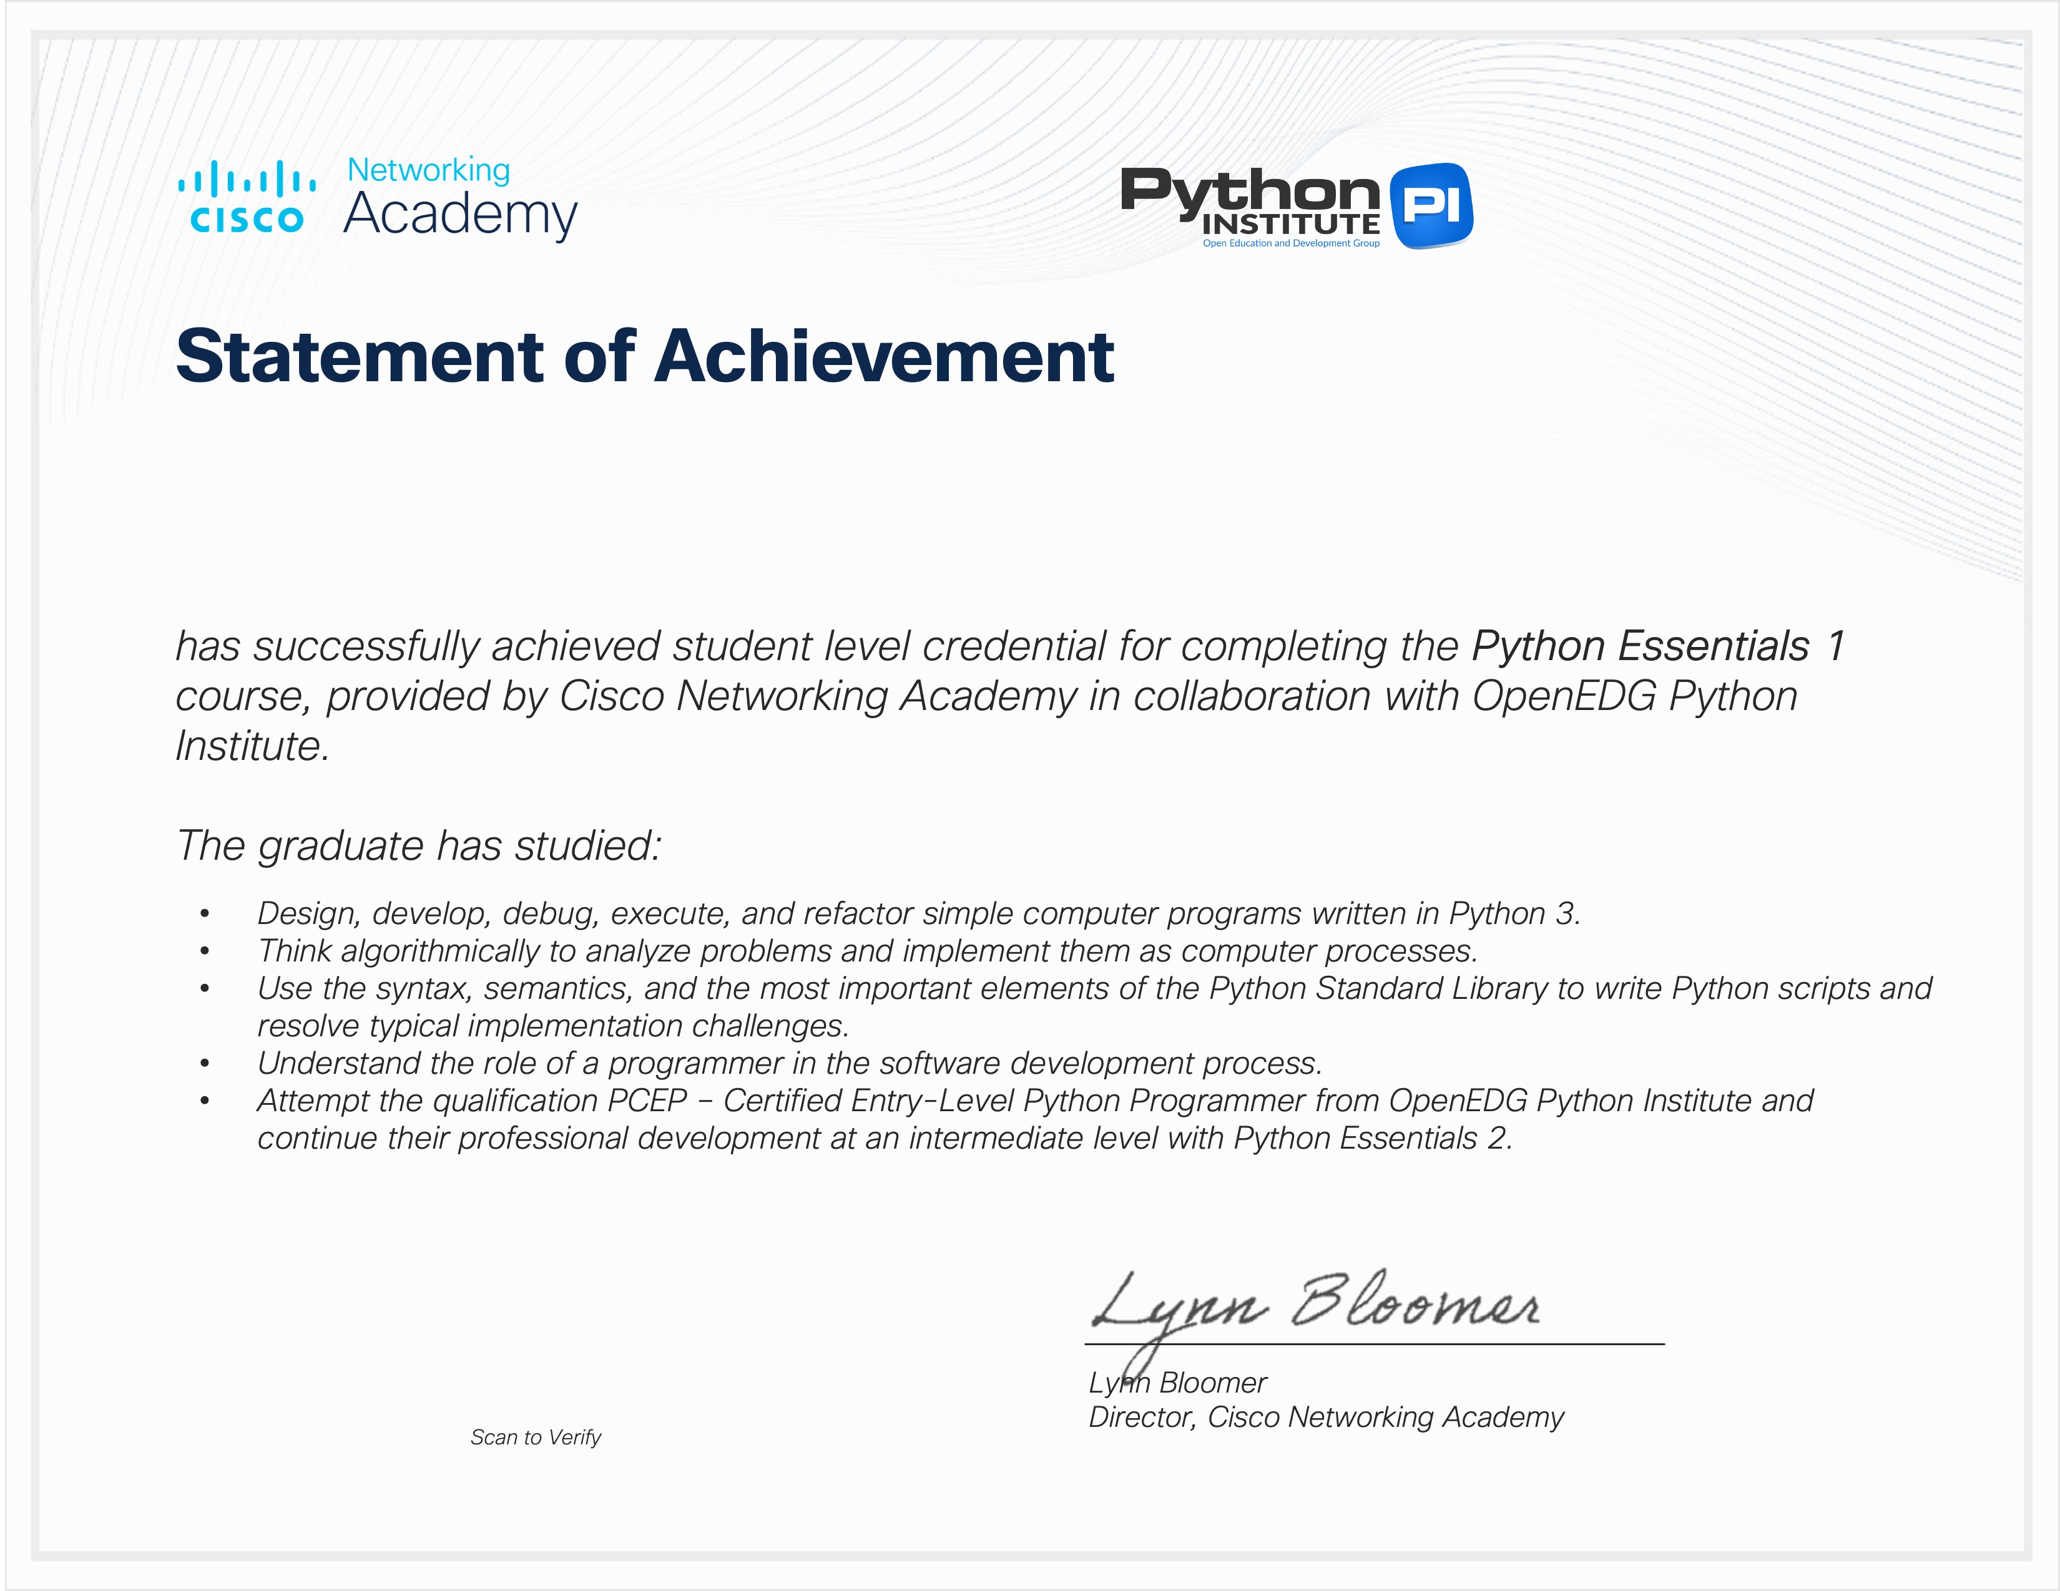


KASHIGARI VENKATRAM
Issued on: Nov 16, 2025

